ASSIGNMENT[26-01-22]:

## QUESTION 1:  Make Regex For the Following.

* POST CODE
* PHONE NUMBER
* EMAIL ADDRESS
* EMPLOYEE ID
* PRODUCT ID

## CODE:

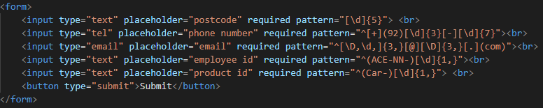

## OUTPUT:

# 1. 2.

# Screenshot 2022-01-27 110349.png Screenshot 2022-01-27 110552.png

## QUESTION 2: Make Pattern for CNIC, details are given bellow: This number comprises three parts. The first part, which comprises five digits i.e. '12101', has its first digit '1' identifying your province. People whose CNIC number starts with 1, are residents of Khyber Pakhtunkhwa province, similarly, 2 represent FATA, 3 for Punjab, 4 for Sindh, 5 represents Balochistan, 6 for Islamabad, and 7 represents Gilgit-Baltistan province. The second digit in the CNIC number shows your division, which means every digit identifies a different division in a province, while the rest of the three-digit represent your district, tehsil, and union council. The second and middle part of the CNIC number, which comprises seven digits separated by hyphens i.e. XXXXX-1234567-X, is basically a code for the family number of a citizen. This code forms the family tree of a citizen. The third part, which has only one digit following a hyphen, represents the sex of a person. For a man, odd digits i.e. 1, 3, 5, 7, 9 are used, while even digits i.e. 2, 4, 6, 8 are used for women.

## CODE:



## OUTPUT:

## 2.

